Aim: Implement algorithms to generate and verify message authentication codes (MACs)
for ensuring data integrity and authenticity.

Input:

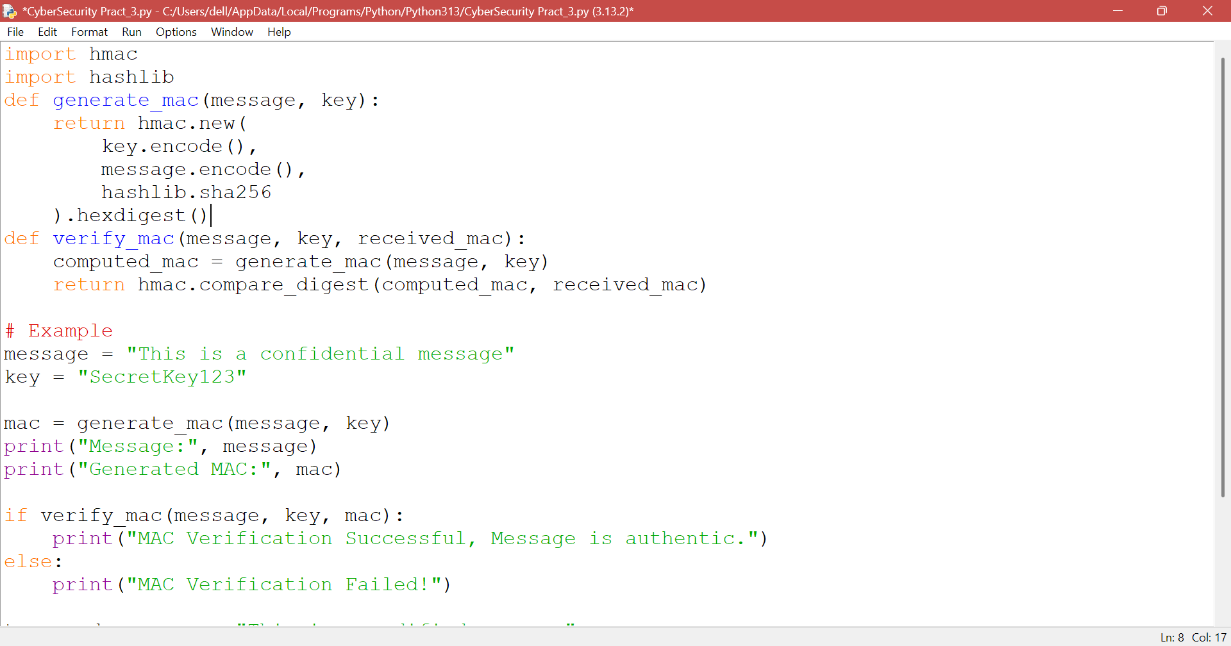
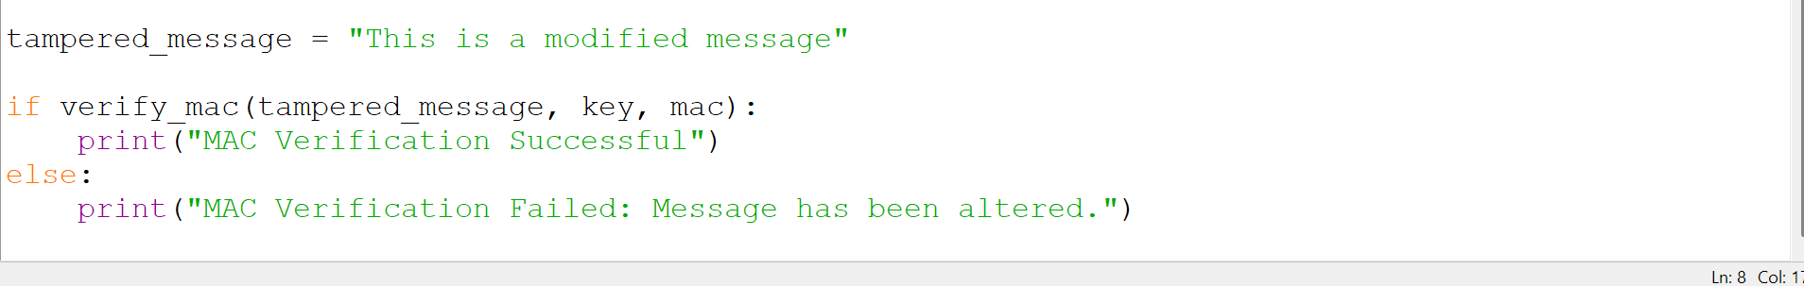

Output:

